SIMATS Engineering
Department of Information Technology

CSA4708 - DEEP LEARNING
ASSIGNMENT 1
CO1 – MATHEMATICAL FOUNDATIONS AND MACHINE LEARNING PRINCIPLES

Name: B Siva Shirish
Reg no:192324016

Scenario: Healthcare Risk Prediction
A hospital plans to develop an intelligent system to predict disease risk using patient age, blood pressure, glucose level, cholesterol and family history. The dataset contains labelled patient records as well as unlabelled records. You are required to analyze the data, select suitable learning approaches and justify decisions using mathematical reasoning.

1 | TASK 1  Patient Data Representation and Normalization | 5  MARKS

QUESTION
A hospital records age, blood pressure, glucose level and cholesterol for three patients. These features have different numerical scales.
a) Explain the likely effect of using the raw features without centering or normalization.
b) Represent the patient data as a feature matrix and apply a suitable normalization procedure using a small numerical example.
c) Explain why normalization is important for distance-based and gradient-based learning methods.
Evidence Expected: Feature matrix, normalization procedure, numerical verification, explanation of scale differences and interpretation.
✎ ANSWER

a Effect of using raw, un-centred features
The hospital records four numerical features measured in different units. For three patients the raw data are:
Patient | Age (years) | Blood pressure (mmHg) | Glucose (mg/dL) | Cholesterol (mg/dL)
P1 | 30 | 120 | 90 | 180
P2 | 45 | 150 | 130 | 240
P3 | 60 | 135 | 190 | 210

Using these values directly, without centering (subtracting the mean) or scaling, causes four problems:
- Large-scale features dominate distances. For P1 and P2 the raw differences are 15, 30, 40 and 60 units. Then d = √(15² + 30² + 40² + 60²) = √6325 ≈ 79.53, and cholesterol alone supplies 3600/6325 = 56.9% of the squared distance, while age supplies only 3.6% (Figure 1).
- Weights become unit-dependent. A learned coefficient for glucose changes by a factor of about 18 if glucose is reported in mmol/L instead of mg/dL, so coefficient size cannot be read as importance.
- Optimisation is slow and unstable. Features with large numeric ranges produce steep gradient directions, while small-range features produce shallow ones, so the loss surface becomes a long narrow valley.
- Poor numerical conditioning. Un-centred columns are strongly correlated with the intercept, making XᵀX nearly singular and the solution sensitive to rounding.
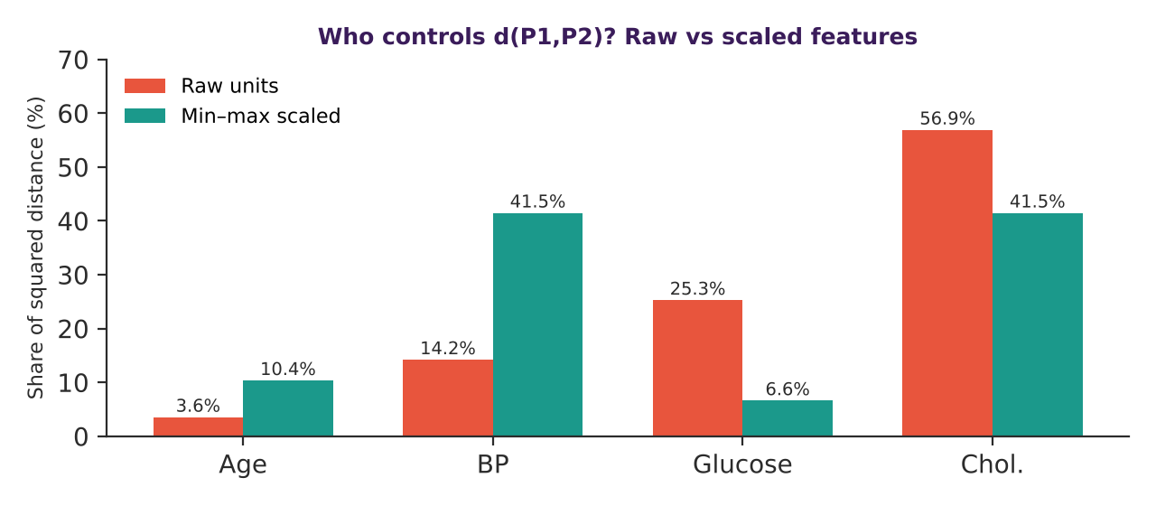
Figure 1 – In raw units cholesterol decides the distance; after min–max scaling every feature has a fair say.
b Feature matrix and normalization with a numerical example
Rows are patients and columns are features, so the data form a feature matrix X ∈ ℝ^{3×4}, with column order (age, BP, glucose, cholesterol):
 | 30 | 120 | 90 | 180
X = | 45 | 150 | 130 | 240
 | 60 | 135 | 190 | 210

I use min–max normalization, which maps every column to [0, 1]:
x′_{ij} = ( x_{ij} − min_{j} ) / ( max_{j} − min_{j} )
Statistic | Age | BP | Glucose | Cholesterol
Minimum | 30 | 120 | 90 | 180
Maximum | 60 | 150 | 190 | 240
Range | 30 | 30 | 100 | 60

Worked example (glucose of P2): x′ = (130 − 90)/(190 − 90) = 40/100 = 0.40. Applying the same rule to all twelve entries gives:
 | 0 | 0 | 0 | 0
X′ = | 0.5 | 1 | 0.4 | 1
 | 1 | 0.5 | 1 | 0.5

Numerical verification. Every column of X′ has minimum 0 and maximum 1, so the transformation is correct. The ordering of patients inside each feature is unchanged (for example glucose: 0 < 0.4 < 1 matches 90 < 130 < 190). Using the same scaling, the distance between P1 and P2 falls from 79.53 to √(0.5² + 1² + 0.4² + 1²) = √2.41 ≈ 1.552, and now BP and cholesterol each contribute 41.5%, age 10.4% and glucose 6.6%.
Alternative: standardization (z-score)
Centering and scaling by the standard deviation, z = (x − μ)/σ, gives zero mean and unit variance. For age, μ = 45 and σ = √150 ≈ 12.247, so z = (−1.225, 0, 1.225). The sum is 0 and the mean square is (1.5 + 0 + 1.5)/3 = 1, which verifies the result. Z-scores are preferred when outliers are present or the model assumes roughly standard-scaled inputs.
Python check of the normalization and the two distances
import numpy as np

# raw feature matrix: age, BP, glucose, cholesterol
X = np.array([[30, 120, 90, 180],
[45, 150, 130, 240],
[60, 135, 190, 210]], dtype=float)

# min-max normalisation, column by column
X_norm = (X - X.min(axis=0)) / (X.max(axis=0) - X.min(axis=0))
print(X_norm.round(3))

def euclid(a, b):
return np.sqrt(((a - b) ** 2).sum())

print("raw distance :", round(euclid(X[0], X[1]), 2))
print("scaled distance:", round(euclid(X_norm[0], X_norm[1]), 3))

[[0. 0. 0. 0. ]
[0.5 1. 0.4 1. ]
[1. 0.5 1. 0.5]]
raw distance : 79.53
scaled distance: 1.552

c Why normalization matters for distance-based and gradient-based methods
Distance-based methods (k-nearest neighbours, K-means, RBF-kernel SVM) compare patients with d(x, y)² = Σ_{j}(x_{j} − y_{j})². Because each term is measured in its own unit, un-scaled features silently receive weights proportional to their variance, exactly as Figure 1 showed. Normalization makes “similar” mean similar across all clinical measurements.
Gradient-based methods update parameters by w ← w − η∇J(w). For a squared-error loss the j-th gradient component is proportional to Σ_{i} x_{ij}·e_{i}, so its size scales with the feature itself. A single learning rate η is then too large for the big-scale feature (divergence) and too small for the others (crawling). The Hessian XᵀX/m has a condition number κ = λ_{max}/λ_{min}; normalization pulls κ towards 1, giving round loss contours, a larger safe η and far fewer iterations.

2 | TASK 2  Vector Representation and Matrix Operations | 2  MARKS

QUESTION
A hospital assigns different importance weights to age, glucose level, blood pressure and cholesterol when calculating a preliminary risk score.
a) Represent one patient's feature values and the importance weights as vectors and formulate the weighted score using vector notation.
b) Use a small numerical example to calculate the score and interpret it.
Evidence Expected: Vector representation, matrix/vector formulation, numerical multiplication and interpretation.
✎ ANSWER

a Vector notation for the weighted score
Using the normalized values, one patient is the feature vector and the hospital’s importance weights form a weight vector (order: age, glucose, blood pressure, cholesterol):
x = [ x_{age}, x_{glu}, x_{bp}, x_{chol} ]ᵀ , w = [ w_{age}, w_{glu}, w_{bp}, w_{chol} ]ᵀ , Σ w_{j} = 1, w_{j} ≥ 0
The preliminary risk score is the dot product, a single matrix–vector multiplication of a 1×4 row with a 4×1 column:
s = wᵀx = Σ_{j=1}⁴ w_{j}x_{j} and for m patients s = X w
b Numerical example and interpretation
Take patient P2 from Task 1 (normalized: age 0.5, glucose 0.4, BP 1.0, cholesterol 1.0) and illustrative hospital weights w = (0.15, 0.40, 0.25, 0.20), where glucose is judged most important.
Feature | x_{j} | w_{j} | Contribution w_{j}x_{j}
Age | 0.5 | 0.15 | 0.075
Glucose | 0.4 | 0.40 | 0.160
Blood pressure | 1.0 | 0.25 | 0.250
Cholesterol | 1.0 | 0.20 | 0.200
Score s |  |  | 0.685

s = 0.15(0.5) + 0.40(0.4) + 0.25(1.0) + 0.20(1.0) = 0.075 + 0.160 + 0.250 + 0.200 = 0.685
Interpretation. On a 0–1 scale, 0.685 is clearly above the midpoint, so P2 would be flagged for closer attention. Blood pressure and cholesterol contribute 0.45 of the 0.685 (about 66%) because both are at their maximum in this group, even though glucose has the largest weight. Computing all three patients at once uses the 3×4 matrix of normalized rows (columns: age, glucose, BP, cholesterol):
 | 0 | 0 | 0 | 0
X = | 0.5 | 0.4 | 1 | 1
 | 1 | 1 | 0.5 | 0.5

s = X w = [ 0, 0.685, 0.775 ]ᵀ , e.g. P3: 0.15(1) + 0.40(1) + 0.25(0.5) + 0.20(0.5) = 0.775
So the ranking is P3 > P2 > P1. If the raw values had been used the same weights would give 0.15(45) + 0.40(130) + 0.25(140) + 0.20(240) = 141.75, a number with no interpretable scale, which again shows why Task 1’s normalization comes first. The weights here are expert opinion for screening; later models in this assignment learn w from labelled data instead.

3 | TASK 3  Probability and Conditional Probability | 6  MARKS

QUESTION
In a sample of 1,000 patients, 200 have a particular disease. Of these diseased patients, 160 have elevated glucose. Among the 800 patients without the disease, 120 have elevated glucose.
a) Calculate the probability that a randomly selected patient has elevated glucose.
b) Calculate the probability that a patient has the disease given elevated glucose.
c) Calculate the probability that a patient has elevated glucose given that the patient has the disease.
d) Explain how conditional probability can support the prioritization of patients for further testing.
Evidence Expected: Event definitions, probability calculations, conditional probability formulae, numerical solutions and healthcare interpretation.
✎ ANSWER

• Event definitions and counts
Let D = “patient has the disease” and G = “patient has elevated glucose”. Then N = 1000, |D| = 200, |Dᶜ| = 800, |G ∩ D| = 160 and |G ∩ Dᶜ| = 120. The counts fill the contingency table:
 | Elevated glucose (G) | Normal glucose (Gᶜ) | Total
Disease (D) | 160 | 40 | 200
No disease (Dᶜ) | 120 | 680 | 800
Total | 280 | 720 | 1000

a P(G): chance of elevated glucose
P(G) = P(G ∩ D) + P(G ∩ Dᶜ) = (160 + 120)/1000 = 280/1000 = 0.28
b P(D | G): disease given elevated glucose
P(D | G) = P(D ∩ G) / P(G) = 160 / 280 = 0.5714 (≈ 57.1%)
c P(G | D): elevated glucose given disease
P(G | D) = P(G ∩ D) / P(D) = 160 / 200 = 0.80 (80%)
Cross-check with the product rule and Bayes
P(G ∩ D) = P(G | D)P(D) = 0.80 × 0.20 = 0.16 ✓ matches 160/1000. Bayes: P(D | G) = P(G | D)P(D)/P(G) = 0.16/0.28 = 0.5714 ✓.

Quantity | Value | Plain meaning
P(G) | 0.28 | 28% of all patients have elevated glucose
P(D | G) | 0.571 | Of flagged patients, 57% are diseased
P(G | D) | 0.800 | Of diseased patients, 80% are flagged
P(D) | 0.200 | Baseline disease prevalence

d Using conditional probability to prioritize testing
Conditional probability turns a measurement into a risk estimate. A patient with elevated glucose has a 57.1% chance of disease versus the 20% baseline, a 2.9-fold increase. For patients with normal glucose, P(D | Gᶜ) = 40/720 = 5.6%, so the odds ratio between the two groups is about 10. A sensible workflow is therefore:
- Priority 1: elevated glucose, so schedule confirmatory testing first. Testing just these 280 patients (28% of the sample) finds 160 of the 200 diseased (80%).
- Priority 2: normal glucose but other risk factors, so follow up routinely and combine with age, BP, cholesterol and family history.
- Careful wording: P(G | D) = 0.80 and P(D | G) = 0.57 are different numbers. Confusing them is the classic “inverse probability” error and would overstate the certainty of a positive flag.
Healthcare interpretation
The result is a screening probability, not a diagnosis. Because 43% of flagged patients are not diseased, the flag should trigger a test, not a treatment.

4 | TASK 4  Bayesian Statistics for Disease Classification | 4  MARKS

QUESTION
A disease affects 10% of a population. A test is positive for 90% of patients who have the disease and for 5% of patients who do not have it.
a) Using Bayes' theorem, calculate the probability that a patient has the disease given a positive test result.
b) Explain the roles of prior probability and likelihood in the posterior probability.
c) Discuss why Bayesian reasoning is useful when medical information is uncertain.
Evidence Expected: Prior and conditional probabilities, Bayes' theorem, step-by-step calculation and interpretation.
✎ ANSWER

a Bayes’ theorem calculation
Define D = disease, + = positive test. The given information is: prior P(D) = 0.10, so P(Dᶜ) = 0.90; sensitivity P(+ | D) = 0.90; false-positive rate P(+ | Dᶜ) = 0.05.
P(D | +) = P(+ | D) P(D) / [ P(+ | D) P(D) + P(+ | Dᶜ) P(Dᶜ) ]
- Evidence by total probability: P(+) = (0.90)(0.10) + (0.05)(0.90) = 0.090 + 0.045 = 0.135.
- Posterior: P(D | +) = 0.090 / 0.135 = 0.6667.
Answer
A patient with a positive test has a 66.7% probability of having the disease, even though the test is 90% sensitive.

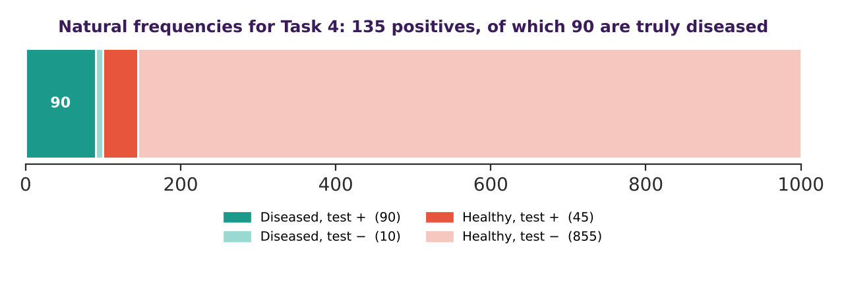
Figure 2 – The same result in natural frequencies: of 135 positives (90 + 45), 90 are truly ill, and 90/135 = 2/3.
Odds check. Prior odds 1 : 9, likelihood ratio 0.90/0.05 = 18, so posterior odds = (1/9) × 18 = 2 : 1, i.e. probability 2/3 ✓.
b Roles of prior and likelihood
The prior P(D) encodes how common the disease is before testing; the likelihood P(+ | D) encodes how strongly a positive result is expected when disease is present compared with when it is absent. The posterior is proportional to prior × likelihood, then normalised by P(+). A strong test cannot overcome a very low prior, as this table shows (same test, different prevalence):
Prior P(D) | P(+) | Posterior P(D | +) | Comment
1% | 0.0585 | 0.154 | Rare: most positives are false
10% | 0.1350 | 0.667 | The given case
30% | 0.3050 | 0.885 | Common: positives are reliable

c Why Bayesian reasoning helps under uncertainty
- Combines knowledge and data. Population prevalence (the prior) and the individual’s test result (the likelihood) are merged in one coherent rule.
- Updates sequentially. If a second independent test is also positive, the odds become 2 × 18 = 36 : 1, a probability of 36/37 ≈ 0.973. A negative test lowers the risk to P(D | −) = 0.01/0.865 ≈ 1.2%.
- Quantifies uncertainty instead of giving a hard yes/no, which fits the way doctors weigh risks and benefits.
- Works with small or noisy data, because a sensible prior stabilises estimates (the idea behind naive Bayes classifiers and Bayesian regularization).
The caveat is that conditional independence between tests and a realistic prior must be justified; a wrongly chosen prior biases every posterior.

5 | TASK 5  Entropy and Information Gain | 3  MARKS

QUESTION
A medical dataset contains 100 patient records: 40 are classified as high-risk and 60 as low-risk.
a) Calculate the entropy of the risk classification.
b) Explain what the entropy indicates about uncertainty.
c) Explain how information gain can help select a useful feature, such as glucose level.
Evidence Expected: Entropy formula, numerical calculation, interpretation of uncertainty and explanation of information gain.
✎ ANSWER

a Entropy of the risk classification
With 40 high-risk and 60 low-risk records, p_{high} = 0.4 and p_{low} = 0.6. Shannon entropy in bits is:
H = − Σ_{k} p_{k} log₂ p_{k}
H = −[ 0.4 log₂(0.4) + 0.6 log₂(0.6) ] = −[ 0.4(−1.3219) + 0.6(−0.7370) ] = 0.5288 + 0.4422 = 0.9710 bits
b What the entropy says about uncertainty
Entropy measures the average surprise when a record’s class is revealed. For two classes the range is 0 (completely pure, no uncertainty) to 1 bit (50 : 50, maximum uncertainty). A value of 0.971 is very close to the maximum, so, without extra information, predicting the risk class of a random record is almost as uncertain as a fair coin flip, even though the classes are not perfectly balanced.
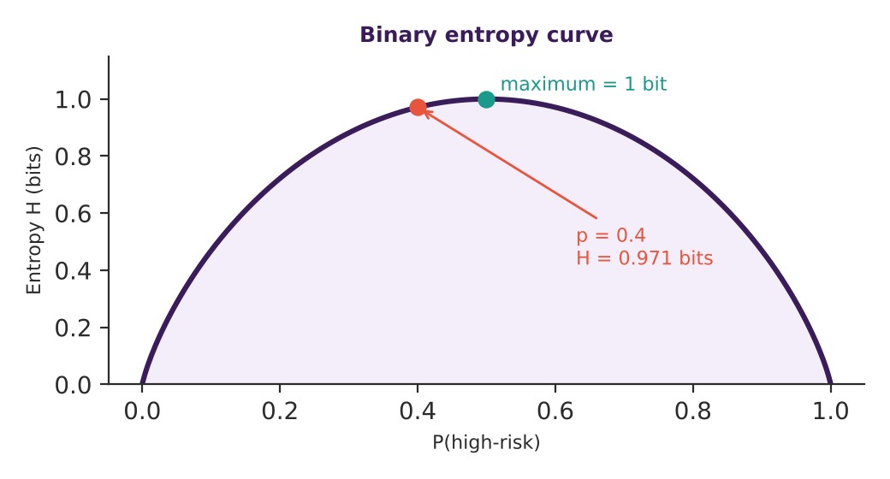
Figure 3 – The dataset sits near the top of the curve (H = 0.971 bits).
c Information gain and feature selection
Information gain is the reduction in entropy after splitting on a feature F:
IG(Y, F) = H(Y) − Σ_{v} (|S_{v}| / |S|) · H(Y | F = v)
To show how it ranks glucose, suppose (hypothetically) that glucose is split into “high” and “normal”, 50 records each: high glucose has 30 high-risk and 20 low-risk records; normal glucose has 10 high-risk and 40 low-risk (the totals still equal 40 and 60).
Subset | Records | High : Low | Entropy (bits)
Glucose high | 50 | 30 : 20 | 0.9710
Glucose normal | 50 | 10 : 40 | 0.7219
Weighted average | 100 | – | 0.5(0.9710) + 0.5(0.7219) = 0.8464

IG(glucose) = 0.9710 − 0.8464 = 0.1245 bits
The feature that yields the largest information gain removes the most uncertainty about risk, so it should be tested first in a decision tree or kept during feature selection. Here glucose reduces the uncertainty by about 12.8% (0.1245/0.9710). A caution: gain favours features with many distinct values, so gain ratio or cross-validation is used to avoid choosing noisy identifiers.

6 | TASK 6  Numerical Computation and Distance Measurement | 3  MARKS

QUESTION
After normalization, Patient A is represented by (0.70, 0.80, 0.60) and Patient B by (0.50, 0.75, 0.90), using glucose, blood pressure and cholesterol features.
a) Calculate the Euclidean distance between the two patients.
b) Explain how the distance can indicate similarity between patient records.
c) Explain why normalization is necessary before comparing features with different scales.
Evidence Expected: Distance formula, step-by-step calculation, similarity interpretation and explanation of normalization.
✎ ANSWER

a Euclidean distance between Patient A and Patient B
Feature order is (glucose, blood pressure, cholesterol): A = (0.70, 0.80, 0.60), B = (0.50, 0.75, 0.90).
d(A, B) = √[ Σ_{j}(A_{j} − B_{j})² ]
Feature | A_{j} − B_{j} | Squared | Share of d²
Glucose | 0.70 − 0.50 = 0.20 | 0.0400 | 30.2%
Blood pressure | 0.80 − 0.75 = 0.05 | 0.0025 | 1.9%
Cholesterol | 0.60 − 0.90 = −0.30 | 0.0900 | 67.9%
Sum |  | 0.1325 | 100%

d(A, B) = √0.1325 ≈ 0.364
b Distance as a similarity measure
A small distance means the two records are close in feature space, i.e. similar clinical profiles; a large distance means different profiles. The largest possible distance between two points in the unit cube is √3 ≈ 1.732, so 0.364 is about 21% of the maximum, a moderate similarity. The table shows that the difference is driven mostly by cholesterol (68%), while blood pressure is almost identical (the gap is just 0.05). For comparison, a third patient C = (0.72, 0.78, 0.58) differs by 0.02 in each feature and lies at only d ≈ 0.035 from A, so C is a much closer neighbour. Nearest-neighbour classifiers and K-means rely on exactly this ranking.
c Why normalization is needed before comparing features
The values above are valid only because they were normalized to the same 0–1 range. In raw units, glucose (about 70–200 mg/dL) and cholesterol (about 150–300 mg/dL) would dwarf blood-pressure differences measured on a different scale, and a 0.05 change in BP would be numerically meaningless next to a 30 mg/dL change in cholesterol. Task 1 demonstrated this: raw distance 79.53 was controlled 57% by cholesterol, whereas after scaling the shares were 10%, 42%, 7% and 42%. Normalization (with training-set statistics) therefore makes the distance a fair, unit-free comparison.
Conclusion
d(A, B) ≈ 0.364 in normalized space: a moderate similarity, driven mainly by cholesterol. It is a statement about the recorded features and must not be read as a clinical verdict.

7 | TASK 7  Bias–Variance Trade-off | 4  MARKS

QUESTION
Three disease-risk models are evaluated. Model A has high training and validation error. Model B has very low training error but high validation error. Model C has low and similar training and validation errors.
a) Identify which model has high bias and which has high variance.
b) Explain how model complexity affects bias and variance.
c) Suggest a suitable improvement for Models A and B.
Evidence Expected: Correct identification, bias–variance explanation, comparison of model behaviour and suitable strategies.
✎ ANSWER

a Which model has high bias and which has high variance
Model | Observed errors | Diagnosis | Meaning
A | High training and high validation error | High bias (underfitting) | Too simple; misses the real pattern even on data it has seen
B | Very low training, high validation error | High variance (overfitting) | Memorises training noise; large gap between training and validation
C | Low and similar errors | Good balance | Generalises well; the preferred model

b How complexity affects bias and variance
For squared-error loss the expected prediction error splits as:
E[(y − f̂(x))²] = Bias²[f̂(x)] + Var[f̂(x)] + σ²
Here σ² is irreducible noise. As model complexity grows (more parameters, higher polynomial degree, deeper trees), the model can approximate the true function more closely so bias falls; at the same time it becomes more sensitive to which particular patients were in the training sample, so variance rises. Total error is therefore U-shaped, with its minimum at the complexity where the two effects balance (see Figure 4 in Task 8). Model A sits on the left of that curve, Model B on the right and Model C near the minimum.
c Suitable improvements
Model A (high bias): make the model more expressive.
- Add informative features or interactions, for example age × blood pressure, or a non-linear transformation of glucose.
- Use a more flexible model (non-linear classifier, deeper network, more trees) and train longer.
- Reduce regularisation strength, then check validation error again.
Model B (high variance): constrain the model or give it more evidence.
- Add regularisation (L2/L1 penalty, dropout), apply early stopping, or reduce depth or parameter count.
- Collect more labelled patients or use data augmentation, since variance falls roughly as 1/N.
- Use k-fold cross-validation, feature selection, or ensembling (bagging) to average out the noise.
Takeaway
Model A needs more capacity; Model B needs less freedom or more data; Model C should be kept and confirmed on an untouched test set.

8 | TASK 8  Overfitting, Underfitting and Model Capacity | 4  MARKS

QUESTION
A simple model fails to capture disease patterns, a moderately complex model performs consistently, and a highly complex model performs almost perfectly on training data but poorly on unseen patients.
a) Identify underfitting, appropriate generalization and overfitting.
b) Explain how model capacity affects the ability to learn complex relationships.
c) Explain why increasing capacity may first improve performance but later cause overfitting.
Evidence Expected: Correct classification of model behaviour, explanation of capacity and relationship with generalization.
✎ ANSWER

a Classifying the three behaviours
Behaviour described | Classification | Reason
Simple model fails to capture disease patterns | Underfitting | Training and validation errors are both high; hypothesis space too small
Moderately complex model performs consistently | Appropriate generalisation | Similar, low errors on seen and unseen patients
Very complex model: near-perfect on training, poor on unseen patients | Overfitting | Fits noise and individual quirks; large generalisation gap

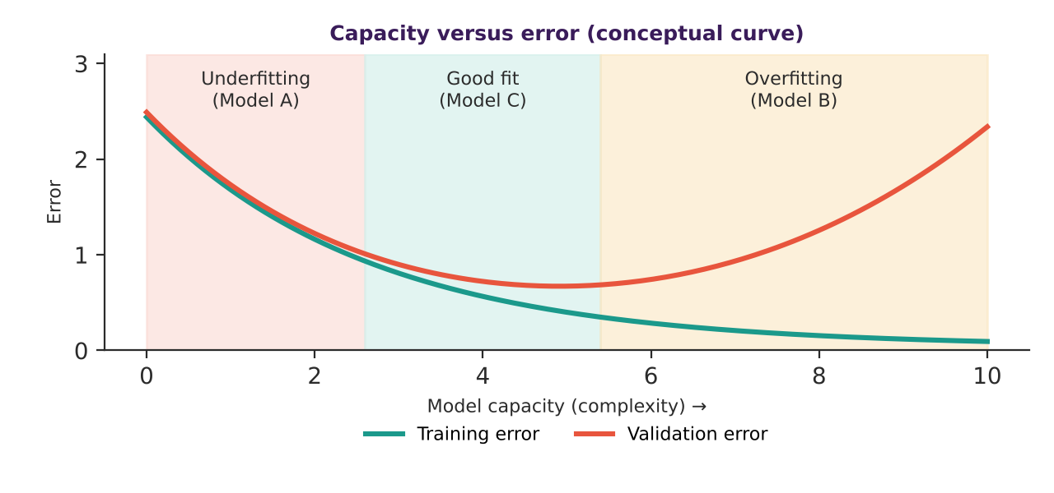
Figure 4 – Training error keeps falling with capacity; validation error is U-shaped.
b How capacity affects the ability to learn complex relationships
Capacity is the range of functions a model can represent (its hypothesis space). A low-capacity model, such as a straight-line risk score, can only draw a flat boundary and cannot represent interactions like “high glucose is dangerous mainly in older patients”. A high-capacity model, such as a deep network or a degree-10 polynomial, can represent very intricate boundaries. Capacity grows with the number of parameters, the polynomial degree, the tree depth or the number of hidden units; regularisation then restricts how much of that capacity is effectively used.
c Why more capacity first helps, then hurts
The generalisation gap (test error minus training error) tells the story. At low capacity, the dominant problem is approximation error: the model cannot even represent the true pattern, so extra capacity lowers both errors. Beyond the point where the pattern is representable, the extra flexibility is spent on fitting random fluctuations in the finite training sample. Training error keeps shrinking, but validation error rises because the estimation error (variance) now dominates. The best capacity therefore depends on the sample size: with more patients the minimum moves to the right.
- Control tools: a separate validation set, k-fold cross-validation, weight decay, dropout, early stopping and simpler architectures.
- Decision rule: choose the smallest model whose validation error is within noise of the best one.

9 | TASK 9  Supervised Learning and Model Evaluation | 3  MARKS

QUESTION
A hospital has historical patient records labelled as diseased or disease-free and wants to predict outcomes for new patients.
a) Explain why this is a supervised learning problem.
b) Describe the roles of training and testing sets.
c) If 92 of 100 test patients are classified correctly, calculate accuracy and interpret it.
Evidence Expected: Identification of supervised learning, training/testing explanation, accuracy calculation and interpretation.
✎ ANSWER

a Why this is supervised learning
Each historical record is a pair (xᵢ, yᵢ), where xᵢ holds age, BP, glucose, cholesterol and family history and yᵢ ∈ {diseased, disease-free} is a known label. The goal is to learn a mapping f : x → y that predicts the label of new patients, which is the definition of supervised learning. Because y is categorical, it is classification; training minimises an empirical loss such as cross-entropy over the labelled pairs.
b Roles of the training and testing sets
- Training set (about 70%): used to fit the parameters of the model.
- Validation set (about 15%): used to tune hyper-parameters and select among models.
- Test set (about 15%): kept locked away and used once at the end to estimate performance on unseen patients. It is stratified so every set has the same disease proportion.
- No patient should appear in more than one set, and scaling statistics are computed on the training set only; otherwise information leaks and the test score becomes over-optimistic.
c Accuracy calculation and interpretation
Accuracy = correct predictions / total predictions = 92 / 100 = 0.92 = 92%
So the model classifies 92 out of every 100 unseen patients correctly. Accuracy alone can mislead when classes are imbalanced. For illustration (hypothetical), suppose 20 of the 100 test patients are diseased:
Hypothetical confusion matrix | Pred. disease | Pred. healthy | Derived measure
Actually diseased (20) | TP = 16 | FN = 4 | Sensitivity = 16/20 = 80%
Actually healthy (80) | FP = 4 | TN = 76 | Specificity = 76/80 = 95%
Accuracy |  |  | (16 + 76)/100 = 92%

A trivial model that predicts “disease-free” for everyone would score 80% accuracy here, so 92% is only a moderate improvement and hides four missed patients. For a hospital, sensitivity, specificity and precision (16/20 = 80%) should be reported next to accuracy, together with a confidence interval, because 100 test patients is a small sample.

10 | TASK 10  Unsupervised Learning and Patient Grouping | 4  MARKS

QUESTION
A hospital has patient records containing age, blood pressure, glucose and cholesterol but no predefined risk labels.
a) Explain why unsupervised learning is suitable.
b) Describe how K-means can group patients with similar characteristics.
c) Explain how distance can be used to measure similarity.
d) Describe how the clusters could support further clinical investigation without replacing medical diagnosis.
Evidence Expected: Learning approach, clustering procedure, distance-based similarity and meaningful interpretation.
✎ ANSWER

a Why unsupervised learning is suitable
The records have features x but no outcome label y. With no target to predict, supervised training is impossible. Unsupervised learning instead looks for structure in p(x) itself, for example groups of patients with similar profiles, without being told what the groups mean. This is useful for exploring a new population and for suggesting hypotheses.
b How K-means groups similar patients
K-means chooses K centroids μ₁…μ_{K} that minimise the within-cluster sum of squares:
J = Σ_{k=1}^{K} Σ_{**x**∈C_{k}} ‖x − μ_{k}‖²
- Normalise the features (Task 1) and choose K (elbow or silhouette plots).
- Initialise K centroids, preferably with k-means++.
- Assignment: place each patient in the cluster of its nearest centroid.
- Update: move each centroid to the mean of its members.
- Repeat steps 3–4 until assignments no longer change; J never increases, so the procedure converges (to a local minimum).
Mini example. Four patients with two normalised features (glucose, BP): P1 = (0.1, 0.2), P2 = (0.2, 0.1), P3 = (0.8, 0.9), P4 = (0.9, 0.8). With K = 2 and starting centroids P1 and P3, P2 joins cluster 1 (d = 0.141 versus 1.06) and P4 joins cluster 2. The new centroids are (0.15, 0.15) and (0.85, 0.85); reassigning changes nothing, so the algorithm has converged with J = 4 × (0.05² + 0.05²) = 0.02.
Python version of the K-means loop used for the mini example
import numpy as np

def kmeans(X, centroids, steps=10):
for _ in range(steps):
# assignment step: nearest centroid by Euclidean distance
d = np.linalg.norm(X[:, None, :] - centroids[None, :, :], axis=2)
labels = d.argmin(axis=1)
# update step: each centroid becomes the mean of its members
new = np.array([X[labels == k].mean(axis=0) for k in range(len(centroids))])
if np.allclose(new, centroids):
break
centroids = new
return labels, centroids

X = np.array([[0.1, 0.2], [0.2, 0.1], [0.8, 0.9], [0.9, 0.8]])
labels, cents = kmeans(X, X[[0, 2]].copy())
print(labels)
print(cents)

[0 0 1 1]
[[0.15 0.15]
[0.85 0.85]]

c Distance as the measure of similarity
Every assignment uses the Euclidean distance d(x, μ_{k}) = ‖x − μ_{k}‖. Patients close to the same centroid are grouped as similar. Because K-means minimises squared distances it prefers compact, roughly round clusters and is sensitive to scale and outliers, which is another reason for normalisation.
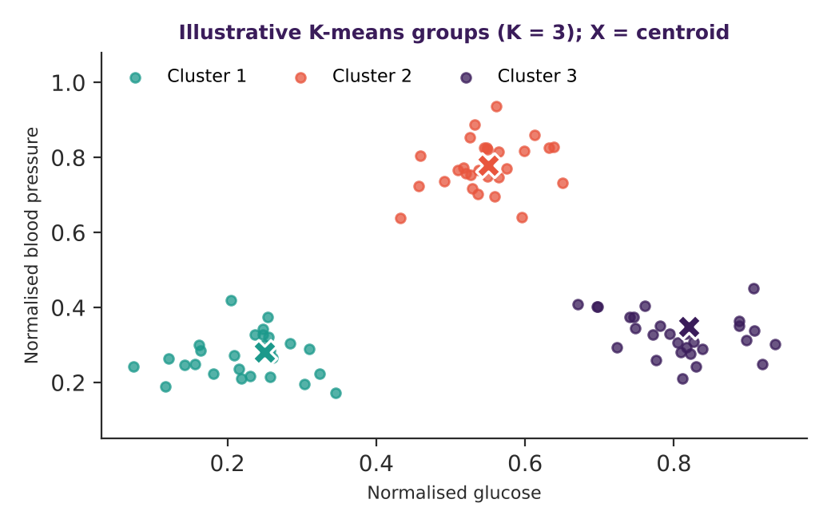
Figure 5 – Illustrative (synthetic) K-means result with K = 3 on two normalised features.
d Supporting clinical investigation without replacing diagnosis
Clusters are hypothesis generators. A clinician can profile each group (average glucose, BP, cholesterol, age), compare outcomes or later diagnoses across groups, and decide whether one group deserves earlier screening, a closer follow-up or a new study. Cluster labels are not diagnoses: the algorithm has no knowledge of disease, K is chosen by the analyst, and the groups can change with different features or random seeds. Stability checks (repeat runs, bootstrap resampling) and expert review must come before any clinical use, and the final decision remains with a qualified doctor.

11 | TASK 11  Comparison of Supervised and Unsupervised Learning | 4  MARKS

QUESTION
Dataset A contains patient features with disease labels, while Dataset B contains patient features without labels.
a) Identify the suitable learning paradigm for each dataset and justify your choice.
b) Compare their objectives and outputs.
c) Recommend an approach for predicting disease status in a new patient and justify the recommendation.
Evidence Expected: Correct identification, comparison of objectives and outputs, and context-based justification.
✎ ANSWER

a Suitable paradigm for each dataset
Dataset A has features and disease labels, so it suits supervised learning (classification): the labels provide the correct answers from which f(x) → y can be learned and measured. Dataset B has features only, so it suits unsupervised learning (clustering, dimensionality reduction, anomaly detection): without a target the only possible goal is to discover structure.
b Objectives and outputs compared
Aspect | Supervised (Dataset A) | Unsupervised (Dataset B)
Input | Features x and labels y | Features x only
Objective | Minimise prediction error, e.g. cross-entropy, to predict y | Optimise a structure criterion, e.g. K-means J, density or reconstruction error
Output | Class or risk probability for a new patient | Cluster ids, low-dimensional embeddings, outlier scores
Evaluation | Accuracy, sensitivity, specificity, ROC-AUC on a test set | Silhouette, stability, domain review; no ground truth
Main risk | Overfitting, label noise, leakage | Arbitrary or unstable groups, over-interpretation

c Recommended approach for predicting disease in a new patient
I recommend a supervised classifier trained on Dataset A, beginning with a regularised logistic regression as an interpretable baseline and comparing it with a tree ensemble. The reasons are: (1) the target, disease status, is exactly what the labels supply; (2) performance can be measured honestly on held-out patients; (3) the output is a calibrated probability that can feed the triage rule from Task 3; and (4) the model can be audited. Dataset B can still help: its cluster membership or distance-to-centroid can be added as an extra input feature, and its unlabelled records can improve normalisation and imputation statistics.
Governance note
Test on a temporal or hospital-held-out split, report sensitivity and specificity, and check calibration before deployment. Unsupervised clusters cannot by themselves tell us whether a new patient has the disease.

12 | TASK 12  Design Challenge: Selecting and Adapting a Learning Strategy | 8  MARKS

QUESTION
Changed Requirement
The hospital initially analyzes 10,000 patient records. It must now process 1,000,000 records, predict disease risk, discover patient groups, and handle missing values and differences in feature scales. Decide whether to retain, modify or redesign the analytical strategy.
✎ ANSWER

Decision in one line: I would retain the mathematical principles (normalisation, probability, distance, capacity control) but redesign the pipeline into a scalable hybrid: calibrated supervised classification plus unsupervised clustering, with proper missing-value handling.
A. Impact Analysis
a) Explain how increasing the dataset size affects data representation, numerical computation and learning efficiency.
b) Discuss why normalization, missing-value handling and data variability are important.

a Effect of growing from 10,000 to 1,000,000 records
Aspect | 10,000 records | 1,000,000 records | Consequence
Memory for X (5 features, 8 bytes) | ≈ 0.4 MB | ≈ 40 MB | Still fits in RAM, but pipelines must be streamed or batched
One full-batch gradient, O(N·d) | 5 × 10⁴ operations | 5 × 10⁶ operations | 100× more work per epoch, so use mini-batch or stochastic gradient
K-means, O(N·K·d·T) | small | ≈ 7.5 × 10⁸ for K = 3, T = 50 | Feasible; mini-batch K-means is faster
Kernel/Gram matrix, O(N²) | 10⁸ entries | 10¹² entries ≈ 8 TB | Infeasible; avoid exact kernel methods and exact k-NN

Representation: the data must be stored as a compact numeric matrix (float32, sparse or columnar storage), with categorical fields such as family history encoded consistently. Numerical computation: summing 10⁶ floating-point values needs stable algorithms (pairwise or Welford updates) to limit round-off, and normalised inputs avoid overflow in exponentials. Learning efficiency: more data lowers variance (roughly ∝ 1/N), so a higher-capacity model becomes justifiable, but only if each training step stays cheap.
b Why normalisation, missing values and variability matter
- Normalisation: a million records come from many devices and units; without common scaling, distances and gradients are dominated by the largest-range feature (Tasks 1 and 6). Fit the scaler on training data; use robust scaling (median, IQR) if outliers are common.
- Missing values: dropping every incomplete record may discard most of the data and bias it if missingness is related to health. Use median or model-based imputation plus a “missing” indicator, and fit imputers on training folds only.
- Variability: differences between hospitals, years and subgroups (concept drift) change P(x) and P(y | x). The design must be validated across such splits and monitored after launch.
B. Evaluation of the Original Approach
a) Evaluate whether a single supervised approach is sufficient for both disease prediction and patient-group discovery.
b) Explain the limitations of labelled learning when useful patterns also exist in unlabelled records.

a Is a single supervised approach sufficient?
No. A supervised classifier estimates P(D | x) and answers “how likely is disease?”. It does not discover which kinds of patients exist, because the groups are not part of its objective, and it ignores any record without a label. Patient-group discovery is a different goal and needs an objective on x alone (such as K-means). The original single-method design therefore covers only half of the new requirement and would also fail on the scale and missing-value demands without a redesigned pipeline.
b Limits of labelled learning when unlabelled data are informative
- Labels are scarce and expensive: confirmed diagnoses need tests and clinician time, so most of the 1,000,000 records may be unlabelled, and ignoring them wastes information.
- Selection bias: labelled patients are usually those who were already suspected, so a model trained only on them may not represent the whole population.
- Hidden structure: unlabelled records reveal subgroups, outliers and the true feature distribution; these improve imputation, scaling and feature design.
- Semi-supervised idea: if points in one cluster tend to share a label (the cluster assumption), unlabelled data can regularise the decision boundary and reduce variance.
C. Adaptation or Redesign
a) Propose a strategy combining supervised classification and unsupervised clustering.
b) Explain how probability, distance measures, normalization and model capacity can be incorporated.

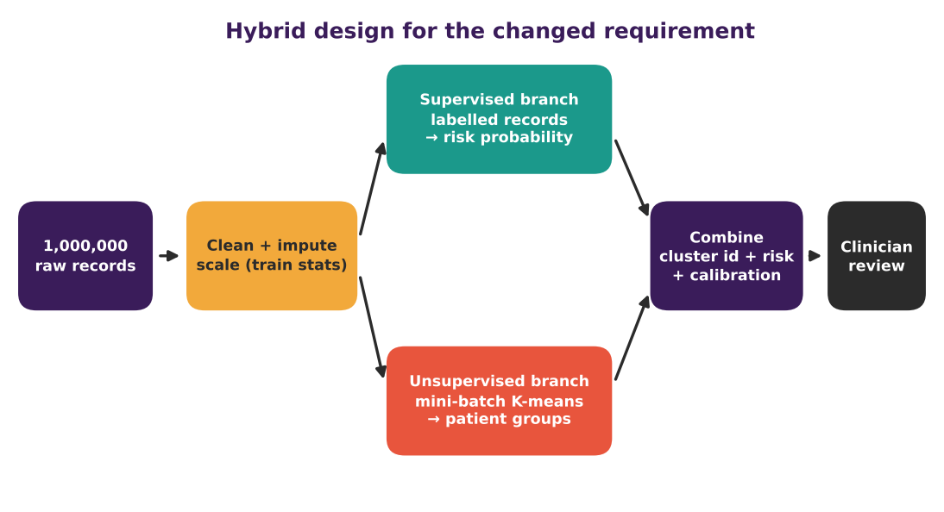
Figure 6 – Proposed hybrid architecture. Both branches share the same cleaned, scaled data.
a A strategy combining classification and clustering
Stage | Method | Reason
1. Ingest and split | Schema checks, stratified and time-aware train/validation/test splits by patient | Prevents leakage and tests drift
2. Pre-process | Impute (median + missing flag), scale using training statistics | Fair distances and stable gradients
3. Supervised branch | Regularised logistic regression baseline, then gradient-boosted trees, trained on labelled rows with mini-batches | Predicts risk P(D | x)
4. Unsupervised branch | Mini-batch K-means on all records (labelled + unlabelled); K chosen by silhouette and clinical review | Discovers patient groups at scale
5. Combine | Add cluster id and distance-to-centroid as features; calibrate probabilities; report risk per cluster | The two branches reinforce each other
6. Review | Clinician dashboard with uncertainty, drift and fairness monitoring | Human decision remains central

b Incorporating probability, distance, normalisation and capacity
- Probability: the classifier outputs calibrated posteriors; Bayes’ rule adjusts for prevalence shift between hospitals, and thresholds are set from the cost of missed disease versus false alarms.
- Distance measures: Euclidean distance on scaled features powers K-means; the distance to a patient’s centroid flags atypical records for review.
- Normalisation: one fitted scaler (training data only) feeds both branches, so features keep the same meaning everywhere.
- Model capacity: start with a low-capacity model, increase capacity only while validation error improves, and use regularisation and early stopping; the larger N supports richer models than at 10,000 records.
D. Evidence-Based Defence | 2 Marks
a) Propose suitable experiments and evaluation measures to compare the redesigned approach with the original.
b) Justify the final design using mathematical reasoning, generalization, computational needs and data characteristics.

a Experiments and evaluation measures
Experiment | Design | Measures
E1 Baseline | Original single supervised model with simple imputation | Reference result
E2 Redesign | Hybrid pipeline of Figure 6 on identical splits | ROC-AUC, PR-AUC, sensitivity at fixed specificity, Brier score
E3 Ablation | Remove one element at a time (scaling, imputation, cluster features, calibration) | Change in each metric
E4 Clustering | Vary K; repeat with bootstrap resamples | Silhouette, within-cluster J, adjusted Rand index for stability
E5 Scale test | Run at 10⁴, 10⁵ and 10⁶ records | Runtime, peak memory, learning curve
E6 Robustness | Hold out one hospital or time period | Drop in AUC, calibration drift

Use stratified 5-fold cross-validation with a final locked test set, report 95% bootstrap confidence intervals for differences, and use a paired test (for example McNemar for accuracy, DeLong for AUC) to decide whether improvements are real and not due to chance.
b Justifying the final design
- Mathematical reasoning: the risk model estimates P(D | x) while clustering minimises J over x; they optimise different, complementary objectives, so neither replaces the other. Normalisation improves the conditioning of both.
- Generalisation: more data cuts variance, capacity is chosen on validation error, and held-out hospital tests check the real generalisation gap.
- Computation: mini-batch learning and mini-batch K-means cost O(N) per pass, whereas exact kernel methods need O(N²) (≈ 8 TB), so the design is feasible at 10⁶ records.
- Data characteristics: imputation and robust scaling handle missing values and heterogeneity; unlabelled rows contribute through clustering, and labelled rows give honest performance estimates.

